**[Vignesh](https://in.linkedin.com/in/vignesh-jayanth-7b481440) Jayanth (University Projects)**

**LS61RJ, Leeds, United Kingdom**

**Email**: [vigneshjayanth00@gmail.com](mailto:vigneshjayanth00@gmail.com)

**LinkedIn**: [Profile](https://in.linkedin.com/in/vignesh-jayanth-7b481440) **Github**: [Profile](https://github.com/vigneshjayanth00/TPD) **Tableau**: [Profile](https://public.tableau.com/profile/vignesh.jayanth#!/)

**Phone**: **07871786016**

1. **Data warehouse Implementation: University Case Study**

**Brief:** Project implementing Star Schema, ETL processes, evaluating effectiveness of various Data warehouse architectures

**Tech Stack:** PL**-**SQL, Oracle APEX, QSEE SuperLite, OLAP- Cognos PowerPlay

**Time Length:** Project time: 5 weeks, Data Size: 1400-2000 rows

**Process:**

The original datasets in the study used were smaller datasets that contained over 1400 and 2000 rows respectively. These were used to feed the dimension and fact tables from the Database source. The Data was fed into the APEX environment using the upload CSV file function under the utilities tab. A star schema was created using the QSEE SuperLite tool. The star schema consisted of one fact table, two-dimension tables and one-time dimension table. The Star schema was not in its normalized form. The data was populated in the fact and dimension tables using the upload data functionality under the utilities tab from the source data (Original Dataset). The functionality allows the user to choose the columns required to be populated (Eg: Facts for facts table). OLAP cubes were created using pivot tables on Cognos PowerPlay. After the scope of the project is defined and the requirements analysis is done, the selection of methodology is a requisite. By referring to the pros and cons of the Kimball/Inmon approaches mentioned in **(El Sappagh et al,2011, (Moscoso-Zea et al,2016),** it gives a good understanding of the most suited approach. Data Warehouse Architecture: Based on the survey study by **(Ariyachandra & Watson, 2008)**, Inmon and Kimball adopted either the hub or bus and spoke architecture. This case study adopted the Bus Architecture

**Grade:** Distinction

**Snapshot:**

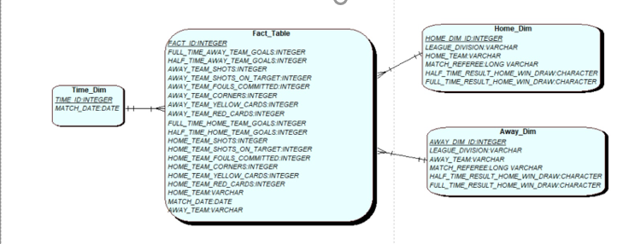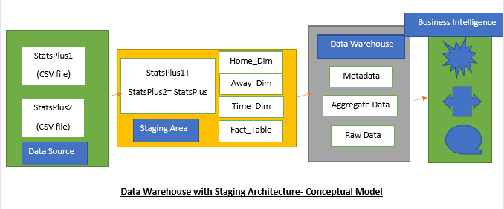

1. **Database Design: University Case Study**

**Brief:** Project implementing Data Security in DB Design, Evaluation of SQL vs NoSQL Database Approaches: Database Implementation

**Tech Stack:** PL**-**SQL, Oracle APEX- Database Security, QSEE SuperLite- Star Schema

**Time Length:** Project time: 5 weeks

**Findings:**

**Database Security Controls:** Based on the report of data security, database security controls were put in place on the application suite. Primarily four areas of security measures were incorporated:

* Authentication Schemes
* Authorization Schemes
* Session State Protection
* Build Options

**Differences between SQL and NoSQL Database Approaches**

|  |  |
| --- | --- |
| SQL Engine vs NoSQL Engine Similarity | SQL Engine vs NoSQL Engine Difference |
| Examples of engines such as MongoDB and Oracle are database management systems that are cross-related to multiple programming languages | Data in NoSQL engines stored using dynamic table schemas as compared to fixed schemas in SQL engines |
| Examples of engines such as MongoDB and Oracle support multiple user databases | NoSQL engines are based on ‘document-oriented schema-less’ database model as compared to a relational model in SQL Engines |

Some key differences between Mongo DB and Oracle DB was suggested based on the study done by **(Mayur M Patil et al, 2017):**

|  |  |
| --- | --- |
| **Mongo-DB** | **Oracle- DB** |
| Schema-Less database model | Relational Database model |
| Query Language consists of API calls | Query language is SQL |
| Value size is 16MB | Value size is 4KB |
| Accepts large amounts of data | Performance is slow for large amounts of data |
| Uses functions for operations such as adding, deleting and updating | Uses SQL language to insert, select, update |
| Uses ‘callback’ functions for advanced queries | Uses PLSQL language for advanced querying |
| It is open source product | It is paid licensed product |

**Grade:** 2:1

**Snapshot**

